-- 1) Who is the senior most employee based on job title?

SELECT * FROM employee

ORDER BY levels DESC

LIMIT 1;



-- 2) Which countries have the most Invoices?

SELECT COUNT(*) total_counts, billing_country

FROM invoice

GROUP BY billing_country

ORDER BY total_counts desc;

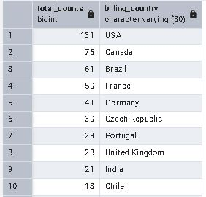

-- 3) What are top 3 values of total invoice?

SELECT total FROM invoice

ORDER BY total DESC

LIMIT 3;

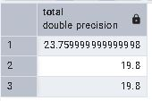

-- 4) Which city has the best customers?

-- We would like to throw a promotional Music Festival in the city we made the most money.

-- Write a query that returns one city that has the highest sum of invoice totals.

-- Return both the city name & sum of all invoice totals

SELECT SUM(total) AS invoice_total, billing_city

FROM invoice

GROUP BY billing_city

ORDER BY invoice_total DESC;

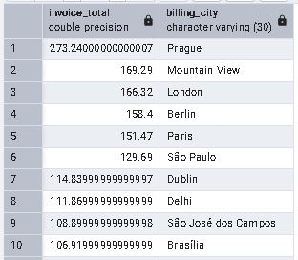

-- 5) Who is the best customer?

-- The customer who has spent the most money will be declared the best customer.

-- Write a query that returns the person who has spent the most money

SELECT c.customer_id, c.first_name, c.last_name, SUM(i.total) AS Total

FROM customer c

JOIN invoice i

ON c.customer_id = i.customer_id

GROUP BY c.customer_id

ORDER By Total DESC

LIMIT 1;

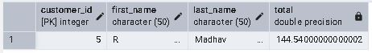

-- 6) Write query to return the email, first name, last name, & Genre of all Rock Music listeners.

-- Return your list ordered alphabetically by email starting with A

SELECT DISTINCT email,first_name, last_name

FROM customer c

JOIN invoice i ON c.customer_id = i.customer_id

JOIN invoice_line il ON i.invoice_id = il.invoice_id

WHERE track_id IN(

SELECT track_id FROM track t

JOIN genre g ON t.genre_id = g.genre_id

WHERE g.name LIKE 'Rock'

)

ORDER BY email;

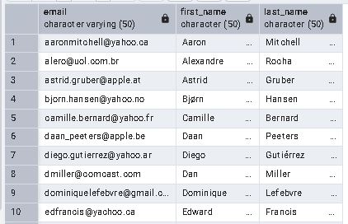

-- 7) Let's invite the artists who have written the most rock music in our dataset.

-- Write a query that returns the Artist name and total track count of the top 10 rock bands

SELECT ar.artist_id, ar.name,COUNT(ar.artist_id) AS number_of_song

FROM track t

JOIN album a ON a.album_id = t.album_id

JOIN artist ar ON ar.artist_id = a.artist_id

JOIN genre g ON g.genre_id = t.genre_id

WHERE g.name LIKE 'Rock'

GROUP By ar.artist_id

ORDER By number_of_song DESC

LIMIT 10;

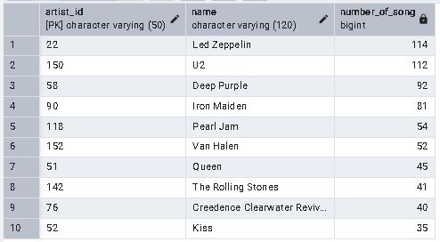

-- 8) Return all the track names that have a song length longer than the average song length.

-- Return the Name and Milliseconds for each track.

-- Order by the song length with the longest songs listed first

SELECT name, milliseconds

FROM track

WHERE milliseconds > (

SELECT AVG (milliseconds) AS avg_track_length

FROM track)

ORDER BY milliseconds DESC;

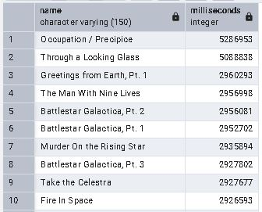

-- 9) Find how much amount spent by each customer on artists?

-- Write a query to return customer name, artist name and total spent

WITH best_selling_artist AS(

SELECT ar.artist_id AS artist_id, ar.name AS artist_name,

SUM(il.unit_price*il.quantity) AS total_sale

FROM invoice_line il

JOIN track t ON t.track_id = il.track_id

JOIN album a ON a.album_id = t.album_id

JOIN artist ar ON a.artist_id = a.artist_id

GROUP BY 1

ORDER BY 3 DESC

LIMIT 1

)

SELECT c.customer_id, c.first_name, c.last_name, bsa.artist_name,

SUM(il.unit_price*il.quantity) AS amount_spent

FROM Invoice i

JOIN customer c ON c.customer_id = i.customer_id

JOIN invoice_line il ON il.invoice_id = i.invoice_id

JOIN track t ON t.track_id = il.track_id

JOIN album a ON a.album_id = t.album_id

JOIN best_selling_artist bsa ON bsa.artist_id = a.artist_id

GROUP BY 1,2,3,4

ORDER BY 5 DESC;

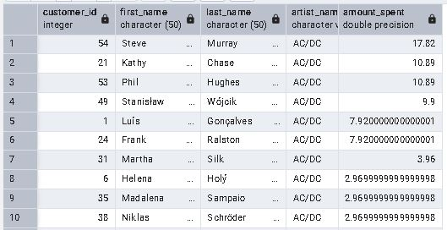

-- 10) We want to find out the most popular music Genre for each country.

-- We determine the most popular genre as the genre with the highest amount of purchases.

-- Write a query that returns each country along with the top Genre.

-- For countries where the maximum number of purchases is shared return all Genres

WITH popular_genre AS

(

SELECT COUNT(il.quantity) AS purchase, c.country, g.name, g.genre_id,

ROW_NUMBER() OVER(PARTITION BY c.country ORDER BY COUNT(il.quantity) DESC) AS row_no

FROM invoice_line il

JOIN invoice i ON i.invoice_id = il.invoice_id

JOIN customer c ON c.customer_id = i.customer_id

JOIN track t ON t.track_id = il.track_id

JOIN genre g ON g.genre_id = t.genre_id

GROUP BY 2,3,4

ORDER BY 2 ASC, 1 DESC

)

SELECT * FROM popular_genre WHERE row_no <= 1;

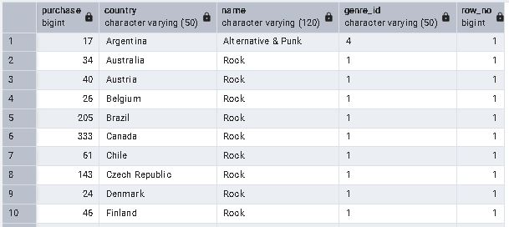

-- 11) Write a query that determines the customer that has spent the most on music for each country.

-- Write a query that returns the country along with the top customer and how much they spent.

-- For countries where the top amount spent is shared, provide all customers who spent this amount

WITH RECURSIVE

customter_with_country AS (

SELECT c.customer_id,first_name,last_name,billing_country,SUM(total) AS total_spending

FROM invoice i

JOIN customer c ON c.customer_id = i.customer_id

GROUP BY 1,2,3,4

ORDER BY 2,3 DESC),

country_max_spending AS(

SELECT billing_country,MAX(total_spending) AS max_spending

FROM customter_with_country

GROUP BY billing_country)

SELECT cwc.billing_country, cwc.total_spending, cwc.first_name, cwc.last_name, cwc.customer_id

FROM customter_with_country cwc

JOIN country_max_spending cms ON cwc.billing_country = cms.billing_country

WHERE cwc.total_spending = cms.max_spending

ORDER BY 1;

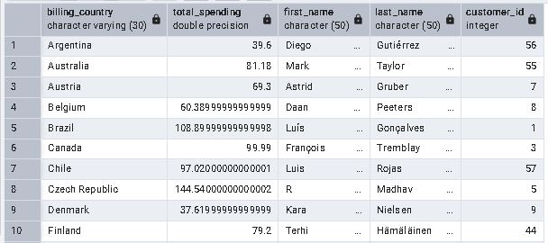

-- Method 2

WITH customter_with_country AS (

SELECT c.customer_id,first_name,last_name,billing_country,SUM(total) AS total_spending,

ROW_NUMBER() OVER(PARTITION BY billing_country ORDER BY SUM(total) DESC) AS row_no

FROM invoice i

JOIN customer c ON c.customer_id = i.customer_id

GROUP BY 1,2,3,4

ORDER BY 4 ASC, 5 DESC)

SELECT * FROM customter_with_country WHERE row_no <= 1;

